

Logo

**[Title]**

**Midyear Report**

**Harvey Mudd College Engineering Clinic**

**Fall Semester Project Team**

Angela Ng

Huong Nguyen

Rachel Roley

Jennifer Zheng

Project Advisor: Prof. David Harris

Project Liaison: Dr. Stephen McCormack

December 2014

ABSTRACT

[Insert abstract here]

*An abstract is similar to a short executive summary. In about 100-150 words, it should summarize the report and the key results in a form accessible to the general reader (e.g. a junior engineering major). Common mistakes in an abstract are to use generalities and to omit the most important information.*

TABLE OF CONTENTS

ABSTRACT ii

1. introduction 1

1.1. Exela Health and Stony brook medicine 1

1.2. Project Statement 1

1.2.1. Objectives 2

1.2.2. Constraints 2

1.2.3. Functions 2

1.3. Deliverables 3

1.4. Project status 5

2. Background 7

2.1. Opioid Overdoses 7

2.2. Naloxone Treatment 7

2.3. Existing Mobile Technologies for Monitoring Vital Signs 9

2.3.1. Hexoskin 9

2.3.2. ViSi Mobile System 11

2.3.3. ZephyrLife 13

3. Impact 14

4. Design Alternatives 15

4.1. ECG Electrode Placement 15

4.2. Design Alternatives: Sensor Integration 15

4.2.1. Vest Embodiment Design 15

4.2.2. Harness Embodiment Design 16

4.2.3. Comparison of Alternatives 17

4.3. Design Alternatives: Microprocessor 18

4.3.1. Intel® Edison Development Platform 18

4.3.2. Broadcom WICED Smart 19

4.3.3. Panasonic PAN1026 19

4.3.4. LilyPad Arduino and nRF8001 Bluetooth Module 20

4.3.5. Comparison of Alternatives 21

5. Detailed design 23

5.1. Respiratory Band and Circuit 23

5.2. Electrocardiogram Electrodes and Circuit 23

5.3. Accelerometer Circuit 23

5.4. Bluetooth Low Energy 23

5.5. WICED SMart BLE and Microprocessor 23

5.6. Android Mobile Application 23

5.7. Overall System Design 23

6. Test plan 25

6.1. Component Testing 25

6.1.1. ECG 25

6.1.2. Respiratory Band 25

6.1.3. Accelerometer 25

6.1.4. WICED Smart 25

6.1.5. Android Mobile Application 25

6.1.6. Data Storage 25

6.2. System Testing 25

7. Project Management 26

7.1. Fall progress 26

7.2. spring overview 28

7.3. Work Breakdown Structure 28

7.4. Schedule 28

7.5. Division of labor 28

8. References 29

# introduction

Exela Health is sponsoring a 2014-15 Clinic Project to build a health-monitoring device that communicates to a mobile phone. This device will collect data that will be analyzed to understand and prevent opioid overdose. This section describes Exela Health, presents the project statement, and defines the deliverables for the project.

## Exela Health and Stony brook medicine

Stephen J. McCormack, Ph.D., is a chief executive officer, entrepreneur, and investor. Passionate about the development of medical products, technologies, and services, Dr. McCormack has worked for over two dozen companies in the medical industry, including Visus, MannKind, CytoMx, and American Optical Services [1]. Exela Health is a new company Dr. McCormack started, focusing on the rapidly expanding field of mobile health.

Stony Brook Medicine is assisting Dr. McCormack in this project to investigate how to medically identify opioid overdose incidents. Stony Brook Medicine is an academic medical center comprised of several health science schools. One of their many research/clinical care teams is currently investigating opioid overdose, particularly as applied to patients who take opioids post joint surgery [2].

## Project Statement

The Harvey Mudd College Exela Health team will build a mobile health monitoring device designed to collect data on patients taking opioids as pain killers post joint surgery. The team will select and integrate appropriate electrocardiogram (ECG), respiratory rate, and motion sensors that communicate with a mobile application via Bluetooth. This application will collect vital sign data and store it in the cloud.

### Objectives

The design consists of both sensors and a mobile application. Objectives for the sensor platform include:

* Comfortable, non-irritating
* Non-intrusive to the patient’s daily life
* Water-resistant
* Wireless communication
* Small and compact
* Easily cleaned/disposable

The objective for the mobile application includes:

* A Bluetooth connection with the sensor platform

### Constraints

The design must meet the following constraints:

* Accommodates patients with a circumference of 38-45 inches
* Sensor platform remains functional on the body for two weeks

### Functions

The design consists of both sensors and a mobile application. The sensor platform should perform the following functions:

* Monitors respiratory rate, electrocardiogram (ECG), and motion
* Transmits data wirelessly to a mobile application
* Stores data on removable media

The mobile application should perform the following functions:

* Collects data from the sensor platform
* Pushes collected data to the cloud

Displays sensor platform connectivity and battery life

## Deliverables

By the end of the fall semester, the team will deliver:

* A proof-of concept capable of collecting data from at least one of the desired sensors
* A basic mobile interface that communicates with the proof-of-concept
* A list of appropriate sensors to be incorporated in the full design
* Multiple design suggestions for allowing users to easily wear the device
* Project documentation and presentations including:
  + Team Charter
  + Work Plan
  + Midyear Report

By the end of the spring semester, the team will deliver:

* A final prototype which includes:
  + A fully integrated platform combining sensors for all desired vital signs
  + A fully functional mobile application that has a stable connection with the sensors
  + Reliable data transmission to the cloud
* Tests performed with the final prototype on team members
* Project documentation and presentations including:
  + Final Report (including engineering drawings)
  + Spring semester presentation at HMC
  + Projects Day presentation
  + Final Presentation at Stony Brook Medicine

## Project status (JZ)

*This section succinctly summarizes what the team has achieved and the status of the deliverables. In doing so, it also outlines the contents of the rest of the report.*

*The team and advisor should have a candid discussion at this point about what has gone well and what has not. If the project has not met the milestones specified in the work plan, the team should come to an understanding of why. In some cases, the direction of the project has shifted in ways that could not be anticipated at the time of the work plan. In other cases, the project has slipped because of insufficient planning (e.g. not realizing that a supplier on the critical path had a 6-week lead time). In yet other cases, part or all of the team may not be putting in the effort required to meet the milestones. This may require some difficult discussions, particularly when members of the team feel the teammates are not pulling their weight. The team should articulate a plan in the Midyear Report to get on track to meet the spring deliverables. However, it is better that issues of team dynamics be addressed verbally within HMC rather than in writing in a way that goes to the client.*

This fall, all of the deliverables given in the previous section were finished and provided to the client. The background research about the diet, habitat, and locomotion of roadrunners and the capabilities and limitations of Acme’s existing products was completed. This information is summarized in Section 2. Section 3 address the potential impact of this project, including changes in roadrunner and coyote populations, the spillover of these changes into the broader ecosystem of the Southwest, and the economic benefits. The team has developed four design alternatives and selected the jet-powered anvil concept for reasons described in Section 4. Section 5 documents the detailed design of the jet-powered anvil, including the SolidWorks model, finite element analysis modeling indicating a maximum velocity adequate to catch a road runner, and a bill of materials. A recent design review at Acme raised several areas that need redesign before manufacturing. This report lists the known issues and plans for modifications; the revised device will be sent for manufacturing in January. Section 6 contains the test plan, including a protocol for animal research.

In the spring, the team plans to manufacture and test the prototype device. Based on test results, an improved second prototype will be designed, built, and tested. The management plan for the second semester is presented in Section 7.

# Background

The scope of the project involves understanding opioid overdoses, Naloxone (“opioid antagonist”) treatment, and existing mobile technologies measuring vital signs.

## Opioid Overdoses

Opioids are often used for patients recovering from surgery or for pain relief. While these drugs are relatively safe for a limited time under a physician's guidance, they can be extremely dangerous when abused. Opioids relieve pain by binding to opioid receptors in the brain. In doing so, they block transmission of pain and increase dopamine levels [3]. As dopamine is related to the reward and pleasure centers of the brain, users may feel a euphoric response to the drug. Over time, opioids will affect the user’s receptors such that they no longer feel the effect they once did.

Drug addiction can often develop among those using opioids for medical reasons. As the effectiveness of a painkiller will decrease over time, doctors often have difficulty determining whether an opioid should be prescribed for a real pain that a patient feels, or if a dangerous dependence is developing. In recent years, opioid addiction and overdose in America has been a growing problem. While the United States only constitutes 4.6% of the world’s population, it consumes nearly 80% of the world’s opioid supply [4]. Opioid related deaths have increased in recent years, with a majority of the deaths accidental.

## Naloxone Treatment

While opioid overdoses present a large medical concern for patients post-surgery, medical advances have provided a short-term pharmacological solution: Naloxone. As mentioned in the previous section, when patients take opioids, the opioids bind to the corresponding receptors in the brain, eliciting a pain-relieving response (Figure 1a) [5]. Naloxone, the "opioid antagonist", blocks and temporarily replaces the opioids on the receptors, treating the overdose (Figure 1b) [5].

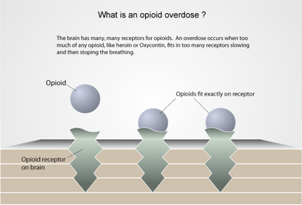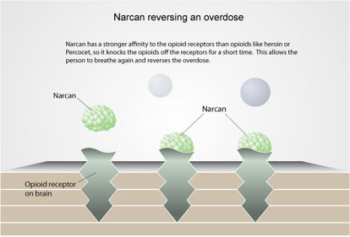

**(a) (b)**

Figure : a) The opioid binds to a receptor on the brain while in b) Narcon (a brand of Naloxone) replaces the opioid in the receptor site of [5].

Naloxone has a half-life between 30 to 81 minutes. Thus, it has to be taken as an injectable solution either intravenously, intramuscularly, or subcutaneously rather than orally [6], [7]. The drug takes effect within 1 to 3 minutes of injection. Afterwards, emergency officials have a window of around an hour to treat the patient before Naloxone wears off [7].

However, Naloxone is not an end-all solution. The effectiveness of the drug depends on the amount of opioid consumed and the dosage of Naloxone administered; for example, if the dosage of Naloxone is only able to occupy 50% of the receptors that bind to opioids, the effects of the opioids will still be present [8]. Also, once the drug wears off, the adverse effects of the overdose will recommence.

Different states have their own versions of legislation for prevention of prescription drug overdose. Generally, Naloxone is a prescribed drug although it differs between states as to who can administer it [9]. While a helpful tool to reduce deaths, Naloxone depends on a quick response time and further medical treatment after it is administered.

## Existing Mobile Technologies for Monitoring Vital Signs

No current technologies measure vital signs specifically to detect opioid overdose. However, there are several products on the market that measure biometrics that the team wants in the desired final prototype. These designs take various forms: sensors incorporated in a shirt, sensors connected to a mobile screen on the body, and a small patch using wireless communication.

### Hexoskin

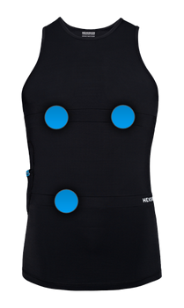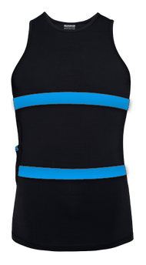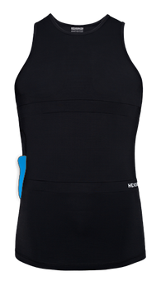

Figure : The blue dots in the left shirt indicate ECG placement, the blue lines in the middle picture indicate respiratory bands, and the blue side in the right picture indicates a motion sensor [10].

Hexoskin (Figure 2) is a shirt with embedded sensors to keep track of several biometrics, including heart rate, heart rate variability (HVR), respiratory rate, and minute ventilation. Data from these sensors are transmitted to a mobile application, from which the user can view any information they are interested in. The mobile application also uploads the collected data to the cloud, and users can log in to the server to download their data for further analysis.  Figure 2 displays Hexoskin shirts, with blue spots indicating where the ECG electrodes, the respiratory rate bands and the motion sensors are [10].

While the Hexoskin is a readily available full-embodiment design[1] with the sensors of interest to the team, there are a few drawbacks to this product. Based on personal observations from the Exela Health Clinic team, the sensor data has noticeable motion artifact. Figure 3a shows the data recorded by the Hexoskin when the wearer moves around and stretches. There is no recognizable pattern or waveform, and the Hexoskin cannot record a reliable value for ECG. Figure 3b and Figure 3c shows the data when the wearer is sitting down and making small movements such as writing. There is still no recognizable ECG pattern, but the Hexoskin does not give out-of-bound values. Figure 3d shows the data when the wearer is sitting very still and not making any significant movements, except for breathing. There is a recognizable ECG pattern, however, there are still some artifacts in the sample.

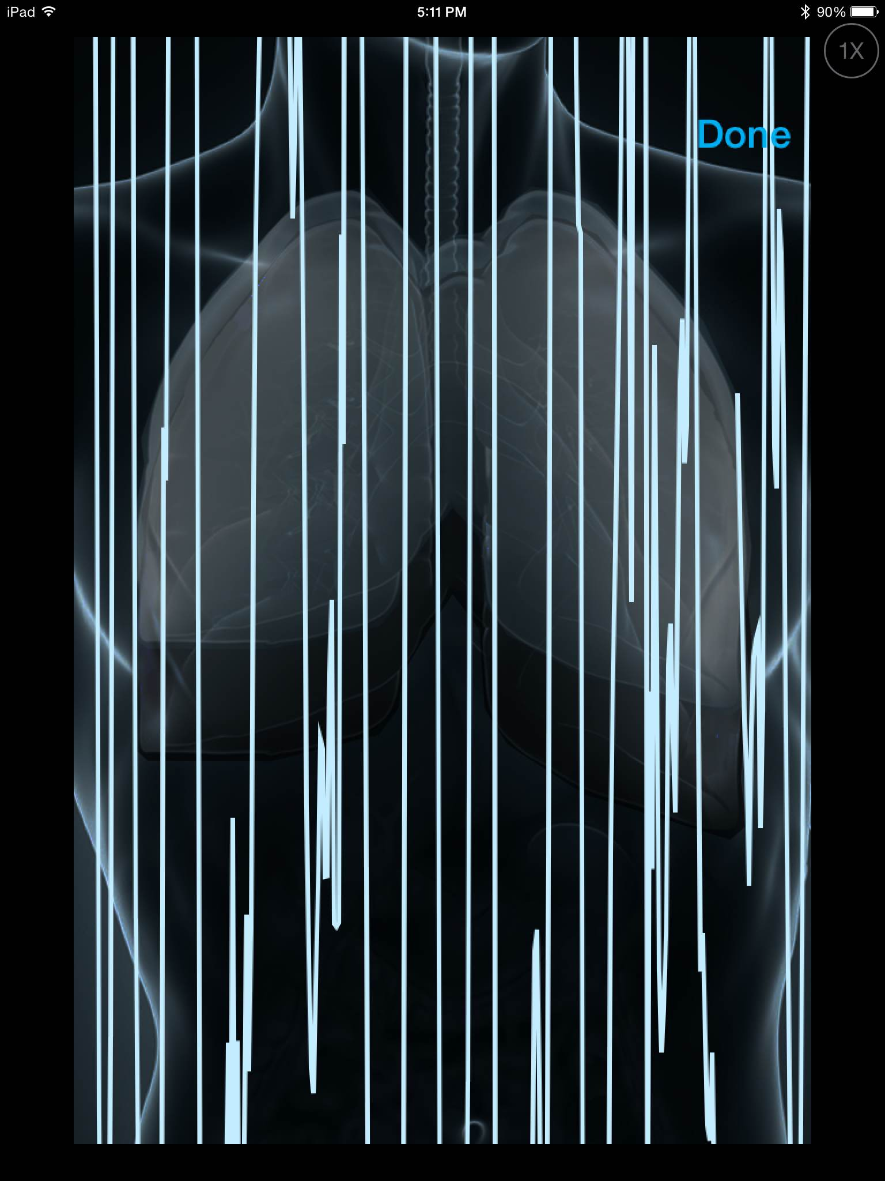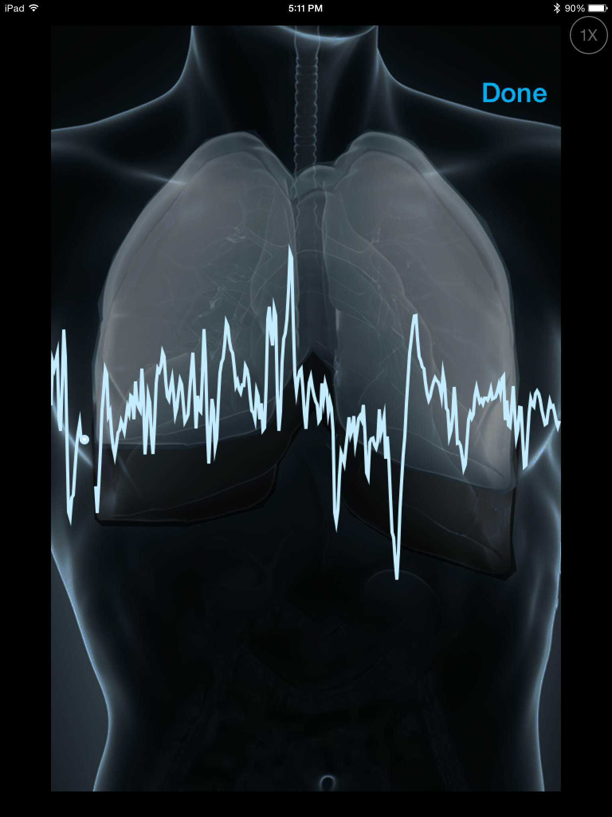

**(a) (b)**

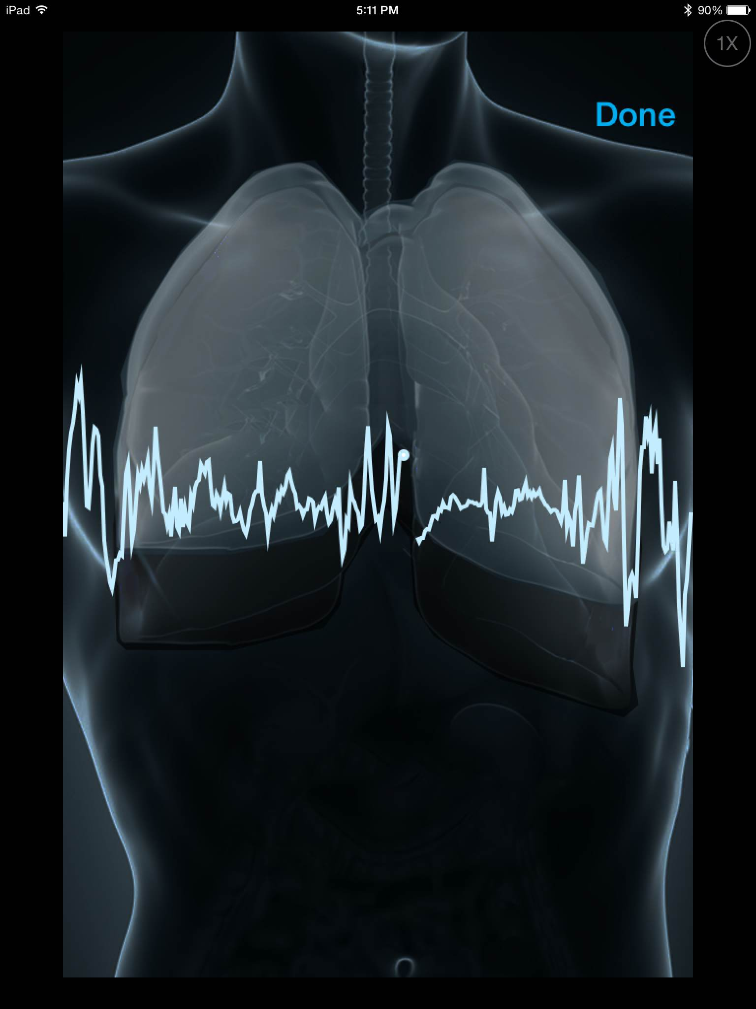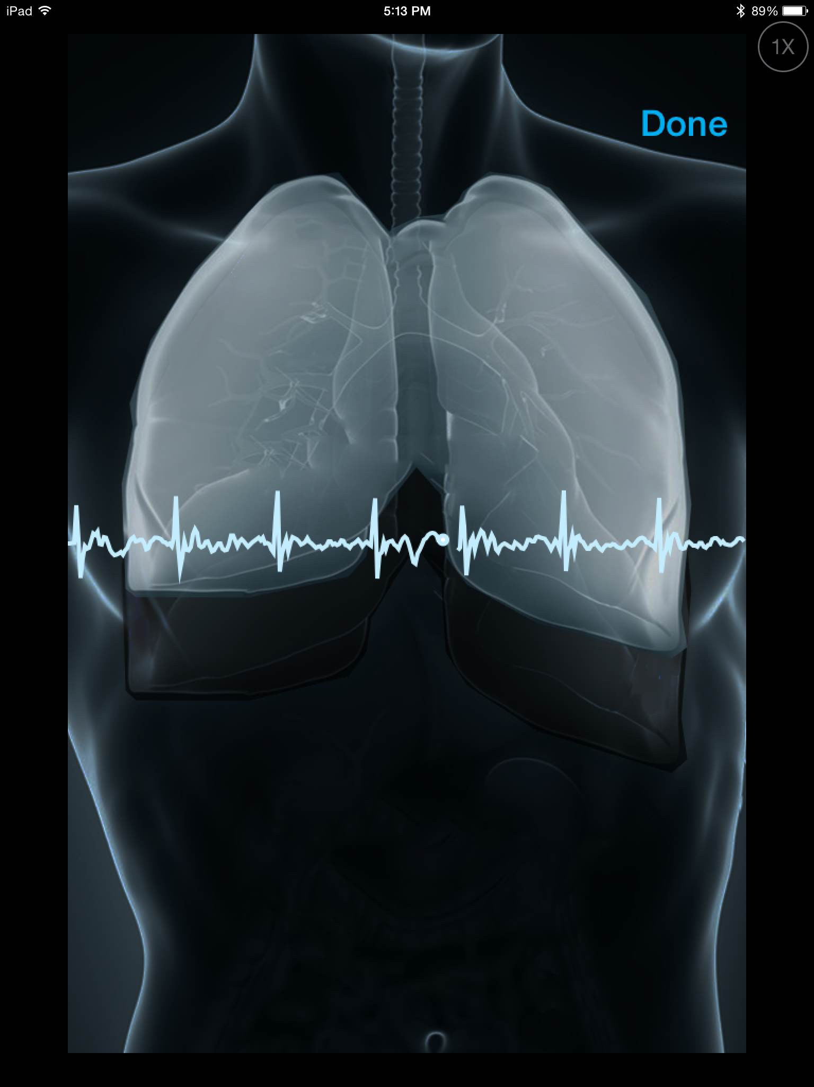

**(c) (d)**

Figure : The data is shown from the team’s trials with the Hexoskin.

The Stony Brook Medicine team also tested out the Hexoskin, and observed that even though the product measures all the necessary vital signs, the data contained too much artifact. This degree of motion artifact is not acceptable for a medical device. Also, while the product has internal data storage, the data is only synced to cloud storage once the device is plugged into a computer, and uploaded to the software HXServices. A patient may view his or her own data on a phone in real-time; however, the data is not transferred to cloud storage simultaneously. This real-time viewing of data is not preferred. For the project, vital signs are recorded for research and not self-diagnosing purposes. In addition to these observations, both the Stony Brook team and the Exela Health Clinic team found that the Hexoskin produced better readings when the shirt fit a patient well. Because the target population of this project includes a wide variety of body shapes and sizes, especially in the morbidly obese category, many different and nuanced sizes of the Hexoskin would need to be produced. This is especially a problem for Hexoskin because the largest size available is XXXL, with listed measurements for men and women that are below the targeted BMI for this project. Finally, the Hexoskin’s $400 unit cost and its battery life of less than 48 hours are additional factors that make Hexoskin non-ideal for the teams’ needs.

### ViSi Mobile System

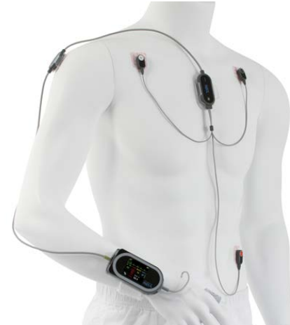

Figure : ViSi Mobile system on the body [11].

The ViSi Mobile System (Figure 4) is a network of sensors wired to a central hub. It can measure and display all vital signs, including ECG, heart rate, SpO2, blood pressure, respiratory rate and skin temperature. The ViSi Mobile sensors boast data accuracy typically found in Intensive Care Units. The ViSi Mobile sensors transmit collected data to the ViSi Mobile monitor, which in turn uploads the data to the hospital backbone (Figure 5). From there, patients and medical professionals can access the data. Figure 4 is the illustration of the ViSi Mobile system network structure [12].

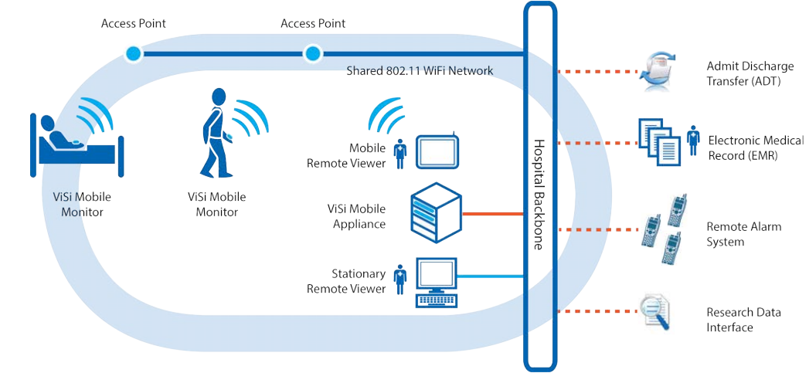

Figure : The ViSi Mobile communicates through a network that allows doctors to view patients’ health without having to be by their bedside [12].

The ViSi Mobile is full-embodiment design that has the hospital standard sensor accuracy. However, FDA regulation requires that only trained professionals can put the system on a patient. Moreover, the system’s central hub is located on the patient’s wrist, which means that wires have to run across the body and along the arm. This can be uncomfortable and inconvenient for the patient.

The Stony Brook team tested out the ViSi Mobile system and had a few observations. First, the system would be difficult for the patient to put on their body and would require a caretaker’s assistance. The system requires adhering multiple components on the body, which would be especially inconvenient for a patient who just came out of surgery and is on painkillers. Second, this product is partly catered towards a military customer base. Because of this, the data that is recorded by the ViSi Mobile system is communicated through to a heavy-duty laptop specifically provided by the company. It is durable, but requires that the system must be used simultaneously with the laptop rather than a personal electronic device. The Stony Brook team is concerned that the system may be difficult for the patient to self-troubleshoot, requiring constant attention by a trained official. Third, the use of the laptop is also an issue because of communication range. The Stony Brook team observed that moving too far from the laptop resulted in data loss. While the target patient population will not likely be mobile, it is inconvenient for the patient if they have to take a laptop with them while moving between rooms.

### ZephyrLife

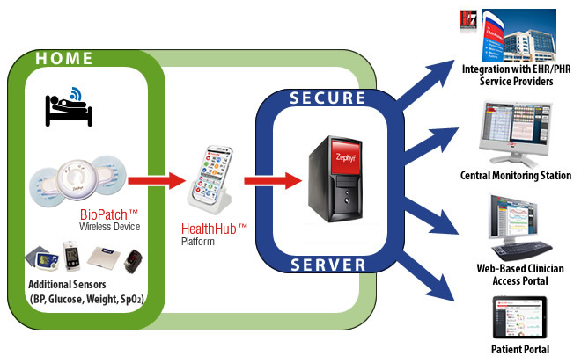

Figure 6: The BioPatch and external devices communicate with a mobile application that stores the data in a server which can be accessed through different interfaces [13].

ZephyrLife (Figure 6) created a remote patient monitoring system capable of collecting data of several biometrics and communicating with a central application. The Zephyr BioPatch Wireless device can measure ECG, respiratory rate, heart rate, heart rate variability, respiration, posture, position and activity minutes. The device communicates with the HealthHub mobile application, which then communicates with a secure server. From the server, medical professionals and patients alike can have access to the data [13].

The BioPatch is a full-embodiment design that is simple for the patient to put on. However, similar to the ViSi Mobile, the system is attached to the body through adhesives which some patients are allergic to. The ECG is a two-lead and the respiratory rate is measured through body impedance which does not meet the project requirements.

*** JZ

# Impact

This mobile health monitoring system has the ability to revolutionize patient health care. When fulfilling its intended purpose, the device will provide post-surgery patients at risk of overdose a more sophisticated warning system. In this way, users will have more immediate access to Naloxone, which is able to reverse the effects of an accidental drug overdose. In a broader sense, it will allow for increased patient monitoring outside of hospitals. This will allow for better diagnosis without a hospital visit, and a greater wealth of data for physicians to analyze.

One possible risk is having patients view their own medical data. The patient’s reaction to their data could be adverse; an individual seeing abnormal data might be unable to stay calm. Alternatively, a patient engaging in risk-taking behavior could use this medical device to gage their risk, effectively putting themselves in near-death situations and using this device to determine when to stop. Under the guidance of the physicians at Stony Brook Hospital, liaison Stephen McCormack, and advisor David Harris, the team has taken this possible negative impact into account. As a result, it will not be possible for users to view their data on the screen, and the data will only be accessible by a qualified physician. Within these constraints, the device will be able to fulfill its intended function to provide a higher quality of care, and save more lives.

# Design Alternatives

The full system design includes three parts: the sensors, the microprocessor, and the mobile application. Based on observations made this semester about competitor products, Section 4.1 highlights a specific design choice for the ECG electrode. The sensors and microprocessor will be integrated into a design that is easy for the patient to wear. Section 4.2 enumerates the sensor integration alternatives presently under consideration and provides an initial comparison of the alternatives.  Section 4.3 presents and describes the microprocessor options. Section 5 how the team plans to complete a detailed design of the preferred alternative, and Section 6 addresses testing.

## ECG Electrode Placement

## Design Alternatives: Sensor Integration

The team is presently considering two design alternatives: vest and harness. This section outlines each of these alternatives and compares the two. The team will flush out conceptual designs for each alternative in the next phase of the project.

### Vest Embodiment Design

The first embodiment design takes the form of a vest worn under normal clothes. The shoulder straps of the vest ensure that all sensors are held securely in place. Two adjustable belt clip-on straps, one along the thorax and one along the abdomen, are incorporated into the vest to tighten or loosen the vest in order to accommodate different body sizes. These straps also function as respiratory bands. Two ECG leads are placed on either side of the upper band. One ECG ground lead will be placed on the bottom adjustable strap. A motion sensor is attached near the center of the vest. The processor is housed in an external pocket positioned between the two respiratory bands. Figure 7 depicts the embodiment design.

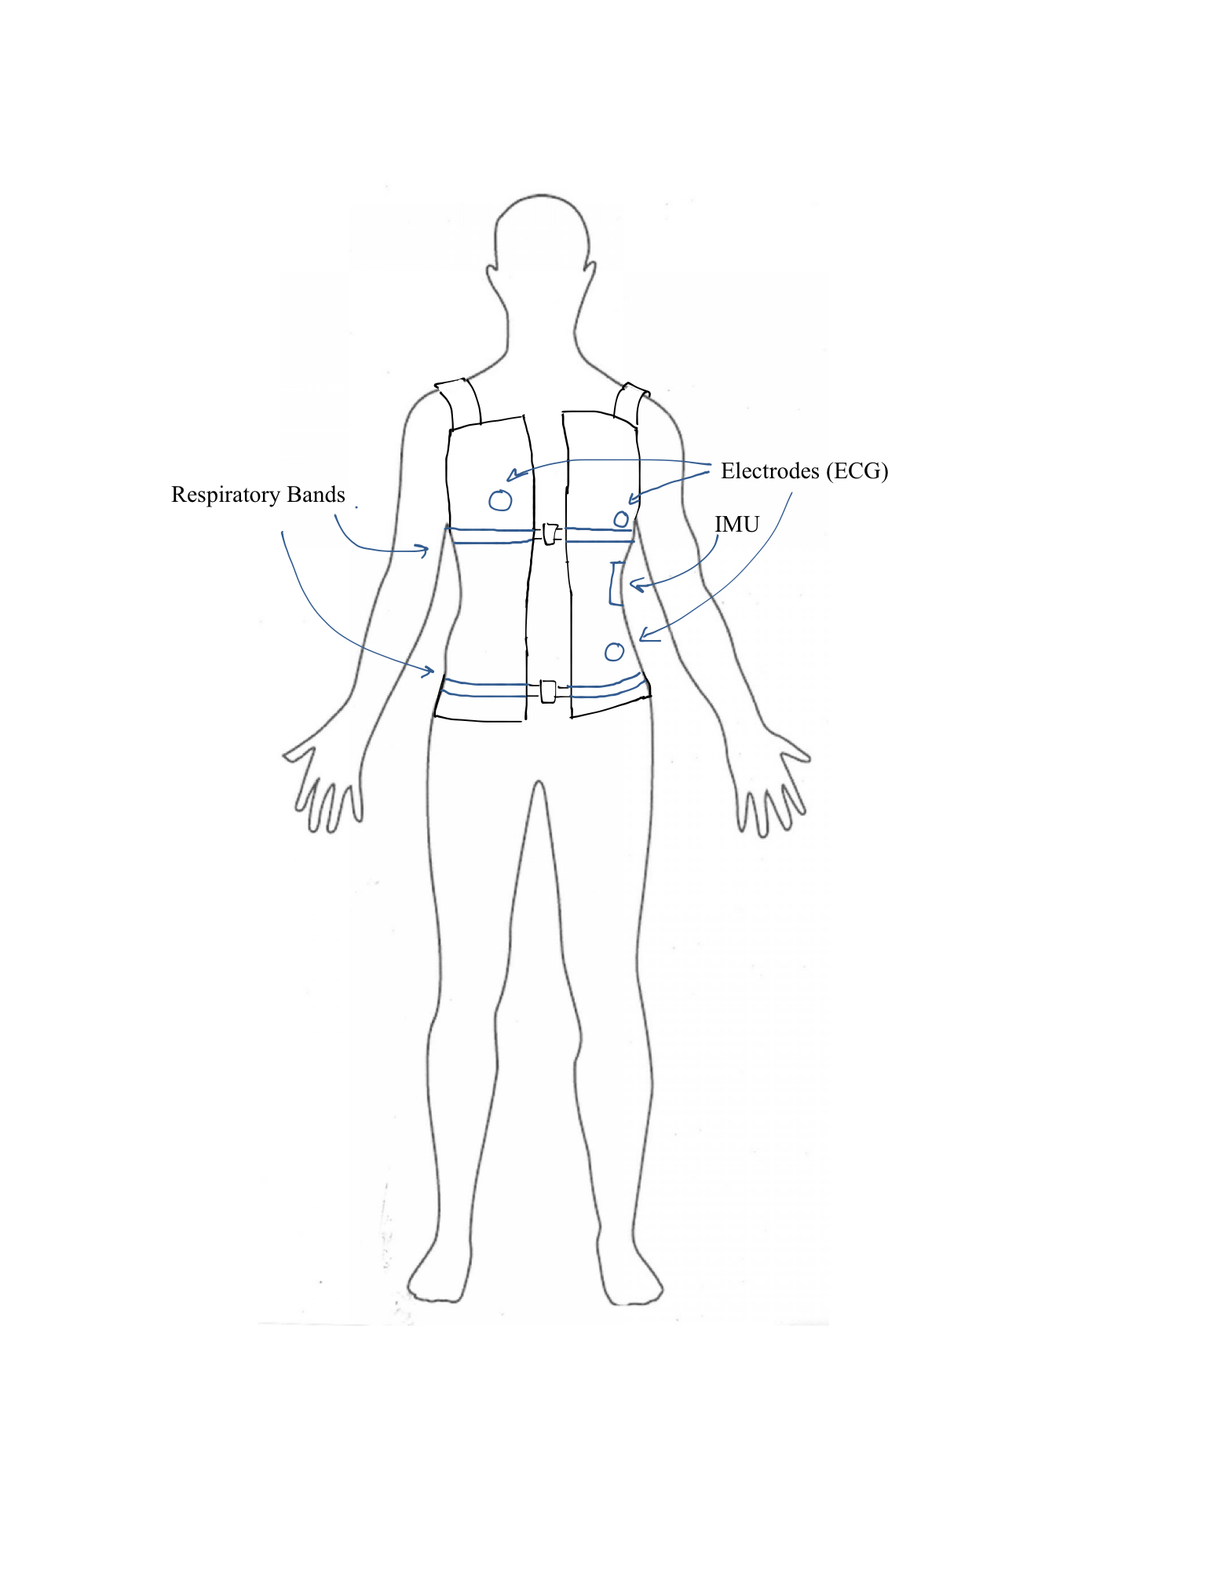

Figure : The vest design is drawn and labeled with ECG, IMU, and respiratory band placements.

### Harness Embodiment Design

The second embodiment design takes the form of a harness. The harness includes two respiratory bands, one on the thorax, and the other on the abdomen. These bands will be attached through clips and have adjustable widths. The band on the thorax will have two electrodes attached on either side, and the band on the abdomen will have the ground electrode attached. There will be straps connecting the upper and lower band to house the processor and motion sensor unit. There will also be over-the-shoulder straps to support the whole embodiment design on the body. Figure 8 depicts a sketch of the harness design.

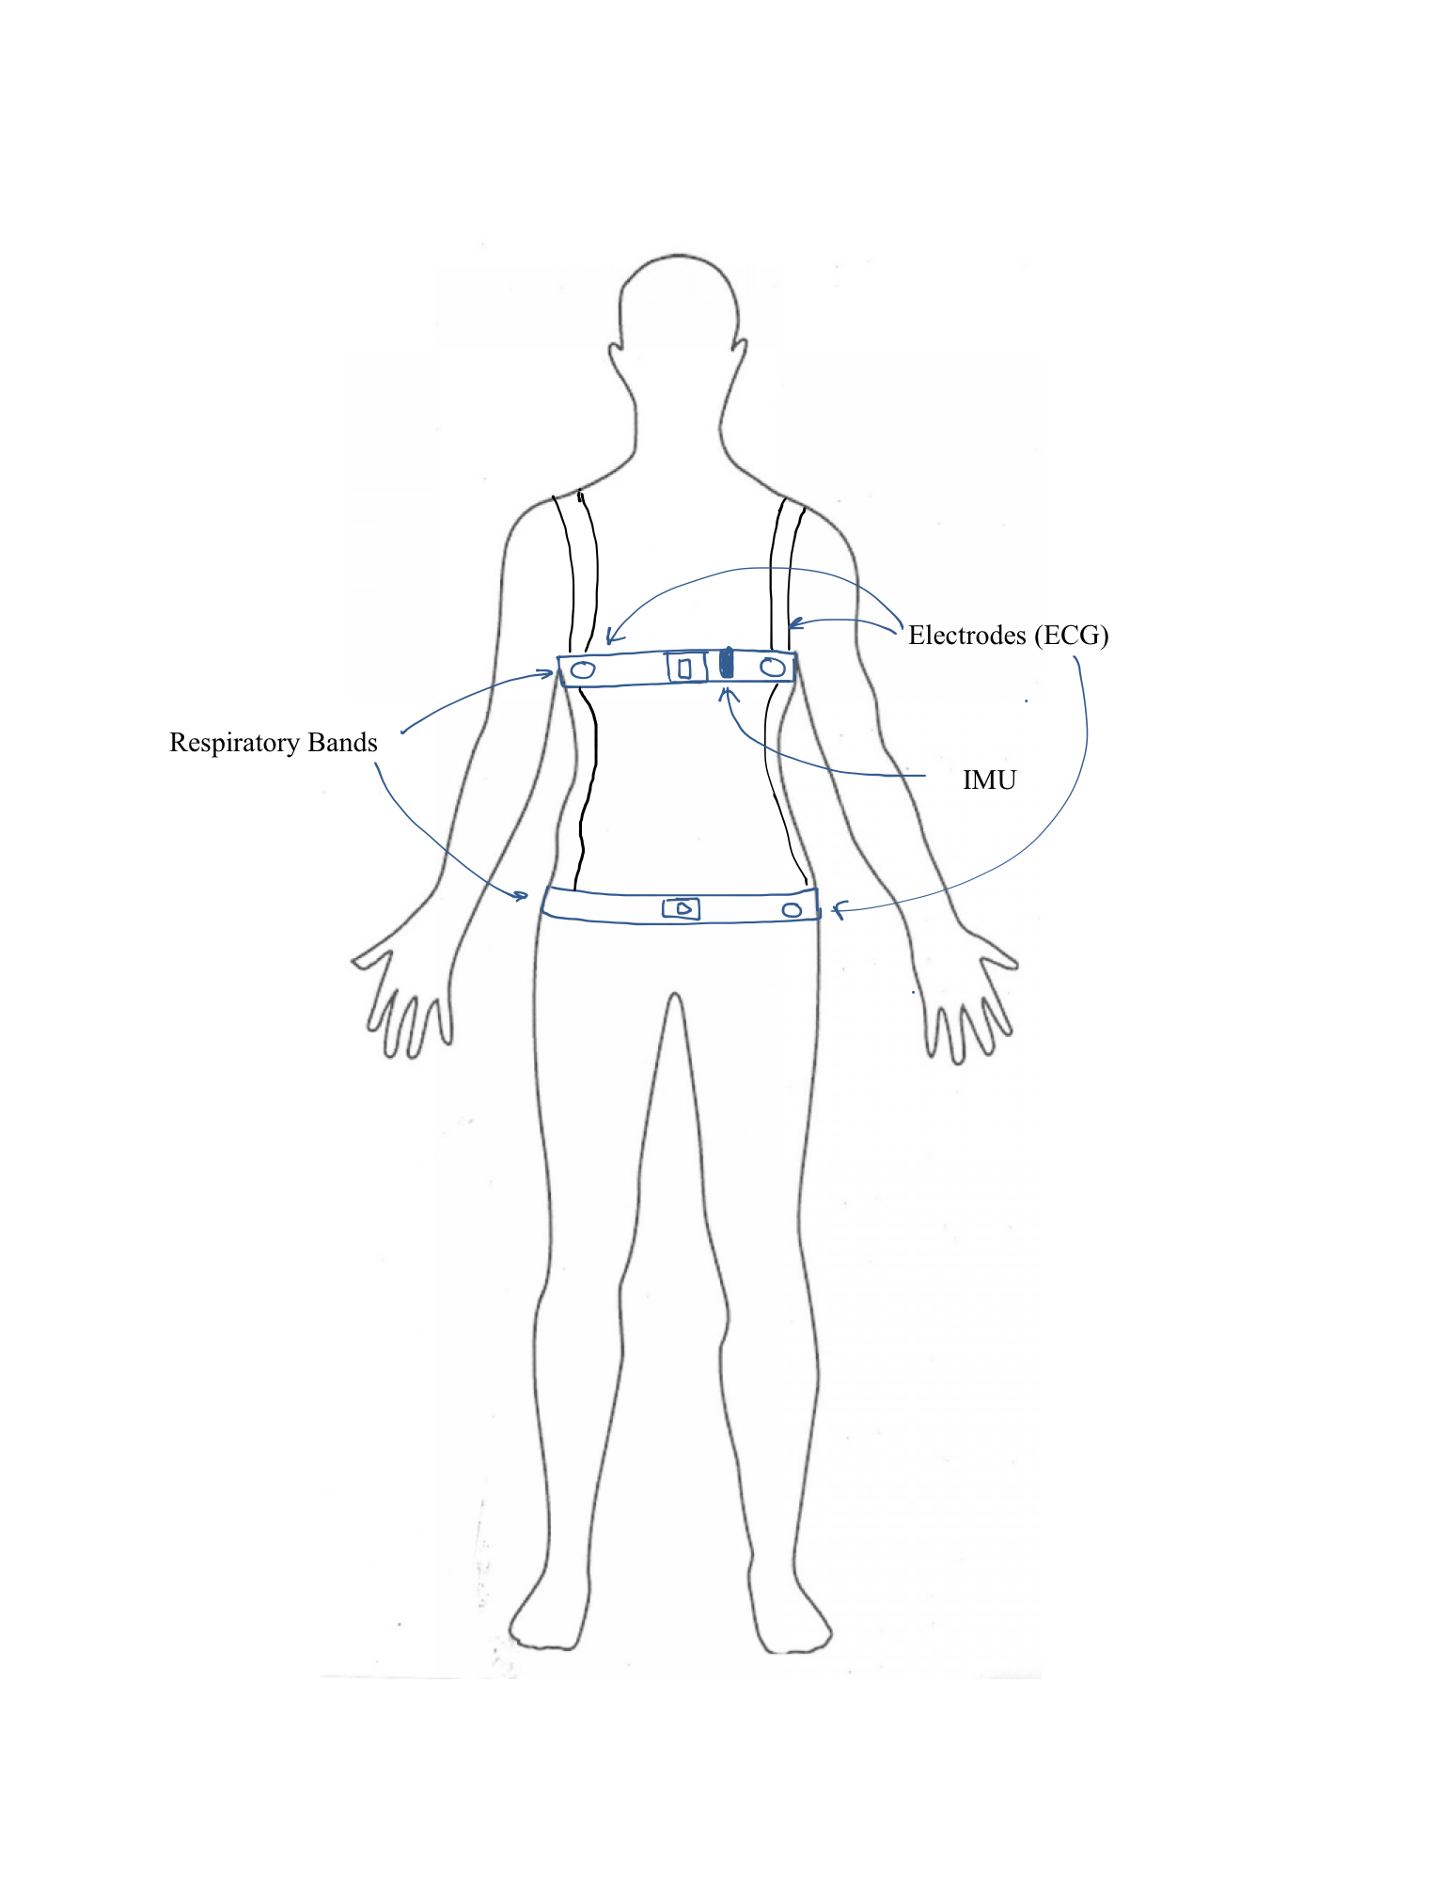

Figure : The harness design is drawn and labeled with ECG, IMU, and respiratory band placements.

### Comparison of Alternatives

Both the vest and the harness designs are capable of securing the sensors to the patient’s body and housing the processor that takes in vital sign data. The vest provides more coverage, thus requiring more materials to manufacture. In addition, Stony Brook Sleep Lab researchers indicated that some patients do not like wearing a shirt while sleeping, and thus will refuse to put the vest on at night. The harness, on the other hand, uses less material to build. However, there are concerns about the tightness of the harness, since being too tight would make the harness uncomfortable to wear, but being too loose would not provide enough support for the sensors attached on the harness.

## Design Alternatives: Microprocessor

The team researched microprocessors with an on-board Bluetooth Low Energy (BLE) module. Four microprocessors were considered for the system: Intel® Edison, Broadcom WICED Smart, Panosonic PAN1026, and LilyPad Arduino. Intel® Edison is discussed in Section 4.3.1, the Broadcom WICED Smart in Section 4.3.2, the Panasonic PAN1026 in Section 4.3.3, the LilyPad Arduino with nRF8001 Bluetooth Module in Section 4.3.4, and the two are compared in Section 4.3.5.

### Intel® Edison Development Platform

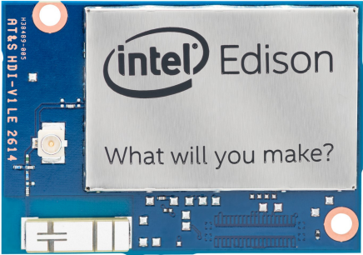

Figure : The Intel® System is attached on the PCB [14]

The Intel® Edison Development Platform (Figure 9) uses a 22nm Intel® System-on-a-Chip that includes a 500MHz duel core Intel® Atom™ CPU and a 32-bit Intel® Quark™ microcontroller operating at 100-MHz clock. It has built-in Wi-Fi and Bluetooth Low Energy modules, with on-board antennas. The Intel Edison runs Yocto Linux v1.6, while supporting development in C/C++, Python and Arduino. The Intel Edison requires an input of 3.3-4.5 V and can operate in the temperature range of 32-104ºF. Sparkfun also developed several add-on blocks for the Intel Edison, most notably the battery block with built-in charger, the 9DOF IMU block that communicates with the microprocessor via I2C, the ADC block and the SD card block [14].

### Broadcom WICED Smart

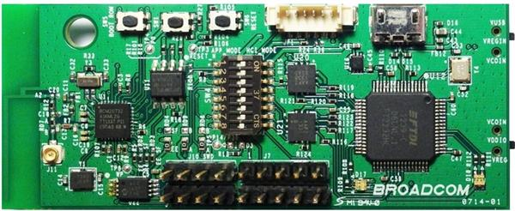

Figure : The Broadcom WICED Smart BLE module [15]

The Broadcom WICED™ Smart Bluetooth Low Energy module (Figure 10) is a very low-power module featuring the Broadcom® BCM2073x-series chip, which includes an ARM® Cortex™-M3 based microprocessor with clock frequency of 24 MHz, 14 GPIOs, 9 of which can be analog, and support for BLE. The WICED™ Smart comes with a Software Development Kit, which simplifies the programming process [15].

### Panasonic PAN1026

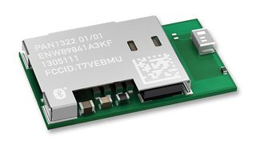

Figure : The Panasonic PAN1026 Bluetooth 4.0 Module [16]

The Panasonic PAN-1026 Bluetooth® 4.0 Module (Figure 11) features an integrated ARM 32-bit microprocessor operating at 26 MHz, Bluetooth Classic and Low Energy Dual Mode, 19 digital GPIOs, and onboard antenna. In order to program the PAN-1026, a Panasonic Evaluation Board EVAL_PAN1026 is required. Depending on what the module is used for, the current consumption is anywhere between 7.8 to 62 mA. The Bluetooth module is 15.6 x 8.7 x 1.8 mm.

### LilyPad Arduino and nRF8001 Bluetooth Module

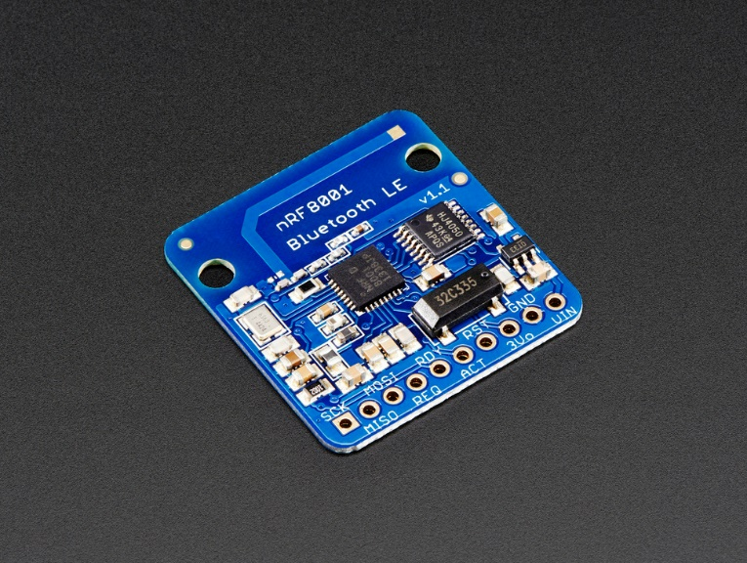

Figure : nRF8001 Bluetooth Module

The Bluefruit LE – Bluetooth Low Energy nRF8001 (Figure 12) is a commercially available Bluetooth module, designed to work with an Arduino controller. The module is an open-source platform, which includes a fairly strong code base and tutorials on how to use the device. As this device is part of the Arduino family, users have access to an extremely strong support community built off these devices. In order to attain full functionality, the device would need to connect to an Arduino based platform. The LilyPad (Figure 13) would best suit the needs of the team, as it is designed for wearables and use in e-textiles. Combined, these two devices would provide the microprocessor functionality of the LilyPad, which includes 14 digital I/O pins and 6 analog pins, and the Bluetooth low energy capabilities of the module [19].

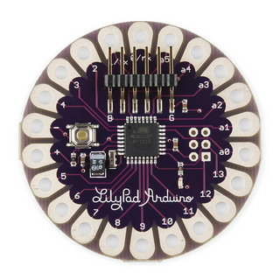

Figure : LilyPad Arudino

### Comparison of Alternatives

The Intel Edison packs excellent processing power into a very small form factor, measuring 35.5 x 25 x 3.9 mm. It also supports all the functionalities that the project requires, such as the BLE module, the microprocessor with up to 40 GPIOs and the various add-on blocks listed above. However, with the 500MHz CPU and several other unneeded features, the Intel Edison far exceeds the power requirement for the project. Furthermore, although the Edison itself is not expensive, the cost of all the breakout boards required to make the Intel Edison a viable alternative for the project would exceed the team’s budget. Moreover, the Intel Edison is currently on backorder, with the earliest estimate arrival at the end of October. This would severely delay the progress of the project and thus should be avoided.

The PAN1026’s clock speed is comparable to that of the WICED Smart, and thus will consume less power than the Intel Edison. The module comes with a software development kit, which allows for easy development. The instruction set for the Panasonic comes with a complete BLE API that, in theory, reduces the time needed to integrate devices. However, since the GPIO pins are all digital and several of the measured vital signs will output analog signals, A/D converters are needed. Using A/D converters will add more hardware, complexity, and power consumption to the system [17][18].

While the LilyPad and the Bluefruit module combined would fit many of the team’s requirements, there are a few clear negatives. The shape of the two boards does not lend for easy combination. While the wires for the necessary connections could be soldered between the boards, the final product would be more likely to fail than a fully integrated system. The required addition of a microSD card reader and accelerometer would further increase the number of connections required between the separate boards. Additionally, the board only has 6 analog pins, which is not enough for the team’s needs without the use of A/D converters. Due to the extra requirements of this board, and the need for additional components, it is not the ideal choice for this application **Error! Reference source not found.**.

The WICED Smart supports all of the key features that the team looks for in a microprocessor. Without too much redundancy, it is a viable option in terms of power consumption. Additionally, the WICED Smart is currently commercially available, priced at $90.28, well within the team’s budget. However, one drawback is that the WICED Smart does not have as open of a support community as the Intel Edison or the LilyPad Arduino do. This makes it harder to find assistance when the team needs it. The WICED Smart also has fewer GPIOs than the other alternatives. Although there are enough pins for the current designs, the possibility of adding more sensors or external modules is slim. However, overall, the WICED Smart is better targeted for the desired application and will best suit the team’s needs.

# Detailed design

*** Intro (JZ)

## Respiratory Band and Circuit

The respiratory bands used in this device are stretchable cloth bands with a wire embedded in a zigzag pattern. This band is based on the technique of Respiratory Inductance Plethysmography (RIP). By Faraday’s law, the current through a loop of wire will induce a magnetic field normal to the orientation of the loop [1]. A change in the area of that loop will change the flux produced. This change in magnetic field allows us to model the band as an inductor. The band’s inductance will change when the band is stretched, i.e. when the area of the loop changes. This change in inductance can be used as an indicator of a patient’s breathing. In order to construct a circuit incorporating the band, its inductance was measured to be 1.4-1.7 µH over a range of stretching. This range was used to calculate further circuit elements, which is detailed in the following sections.

[1] http://www.aastweb.org/resources/focusgroups/rip_intro.pdf

### LR Circuit

This circuit establishes a simple voltage divider, with the respiratory band in series with a resistor. This circuit works on the principal that a change in inductance will change the voltage read over the divider. In order to make the circuit, a number of design constraints were chosen in order to define a value for the resistor.

#### Design Constraints

Table : Design Constraints for LR Circuit

|  |  |
| --- | --- |
| **Constraint** | **Reasoning** |
| The impedance of the resistor and the inductor must be equal (ZL=ZR ) | Relatively equal drops over both sides of the voltage divider are desirable for measuring purposes. |
| Maximize Frequency, within the constraints of equipment used, ~15 MHz | As ZL = jωL, and the power is determined by P=I2/R, maximizing frequency will minimize power |
| Vcc = 3.3 V | This is a reasonable amount of voltage for the WICED to supply |

Within these constraints (Table 1), and knowing the measured inductance of the respiratory band to be in the range of 1.4-1.7 uH, the desired resistor value will be 21 Ω.

This gives the final circuit diagram seen in FIGURE X.

#### Data and Error

Data was collected from this circuit with a National Instruments DAQ over the course of multiple pulls on the band. This DAQ was chosen as it has 16 bits of resolution, the same number of bits of resolution as the WICED. As is possible to see in Figure 14, the voltage output of the circuit is centered around 0V and oscillates between approximately -1.7V to 1.7V. This follows from the design constraints, as the 3.3V input is approximately divided in half.

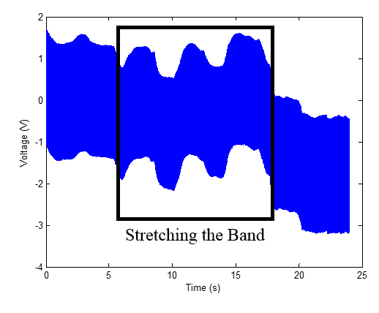

Figure : An image of a respiratory band being stretched three times in succession.

The circuit is, however, extremely susceptible to noise. As is visible in Figure 15, there is considerable noise present in the circuit. The data in the figure shown was collected while the respiratory belt was entirely untouched. An experimenter moved next to the circuit, both walking by (initially), and then making large gestures.



Figure : This graph shows the noise due to movement.

Considering the model of the respiratory band as an inductor, it is necessary to consider the effect of a variable electric field on the device’s output. Specifically, the electrical field of a human body is capable of significantly changing the inductance readings, especially when that moving body represents a variable electric field. This is a problem inherent to the circuit, and it is thus necessary to abandon this design for one which the circuit is not as susceptible to these changes.

### LC Circuit

The LC circuit used in this application is based off a Colpitt’s oscillator circuit. This circuit will take in a DC Voltage input. The circuit makes use of an inductor (the respiratory belt) in parallel with a capacitor. This element, the LC tank, is placed within a feedback loop such that the measured output will be an alternating current signal. This signal will be oscillating at the resonant frequency, defined as the frequency at which the impedance of the inductor and capacitor are equal. [2] Given a known capacitor value and resonant frequency, it is possible to find an unknown inductor value. A theoretical diagram of this circuit is seen in Figure D.

[2] http://www.allaboutcircuits.com/vol_2/chpt_6/6.html

#### Choosing Capacitor Values

The design constraints for this circuit are to minimize the resonant frequency while maintaining a reasonable response time and a stable circuit. As seen in equation Q,

***EDIT NEEDED

Knowing that the inductance has the small value of 1.4-1.7µH, a minimized resonant frequency would require a maximized capacitor value. However, this will require a larger charging time for the circuit, and greater instability. In order to determine these values, as well as other circuit elements that would produce the desired effects, MultiSim was used to determine the theoretical output of the circuit, as seen in Figure 16.



Figure : A MultiSim simulation of the Colpitt’s oscillator circuit with C = 3.6 µF.

#### Data Collection

Data was collected from the circuit, at the node specified in Figure D. After initial test results, the capacitor values of 3.6 µF were determined to be too large and resulted in no oscillation. After decreasing the capacitor values to (some ones I found lying around), the data shown in Figure X was collected. Using an Agilent 53132A 225 MHz Universal Counter, a frequency of 122 KHz was detected.



Figure : The data from the oscillator circuit, with C=(measure this) (900 nf?).

Future work will focus on interfacing this circuit with the WICED, using a frequency counter to give the output of the circuit to the WICED.

## Electrocardiogram Electrodes and Circuit

## Accelerometer Circuit

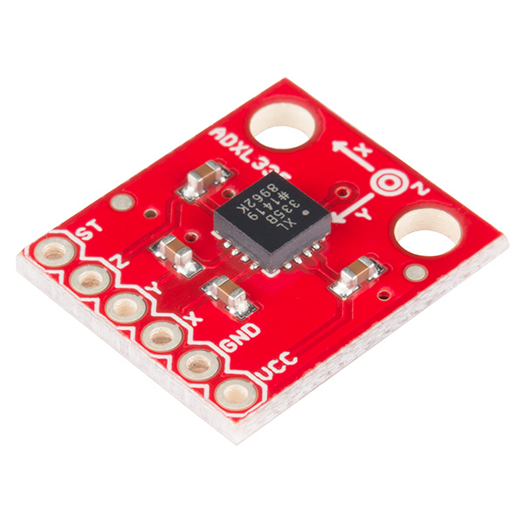

Figure : The 3-axis ADXL335 accelerometer [21].

The accelerometer will be positioned on the body as a measure of the patient’s activity. Because motion artifact can disrupt physiological signal measurements, the accelerometer readings can give some insight into why respiratory or ECG readings may be unreadable or inaccurate.

For this project, a 3-axis accelerometer was chosen, which measures acceleration vectors in the x-, y-, and z-axes. The ADXL335 3-axis accelerometer (Figure 13) will be incorporated into the design. It measures a range of ±3*g* and takes an input voltage range of 1.8 – 3.6 V, within the voltage range the WICED can supply. Based on these specifications, the team found the ADXL335 would be simple to integrate into the system, while meeting design constraints [22].

Preliminary accelerometer data recorded by an NI DAQ is shown in Figure 19. On each of the three axes, data was recorded of a team member jumping up and down, standing up and moving (from left to right to left), and sitting still. The accelerometer was placed on the side of the torso. While there is not much difference between moving and sitting (the offset difference between the sitting and other two signals is due to the accelerometer being slightly angled when the individual was seated versus when the individual was standing up), there is an appreciable difference between the sitting and jumping data.

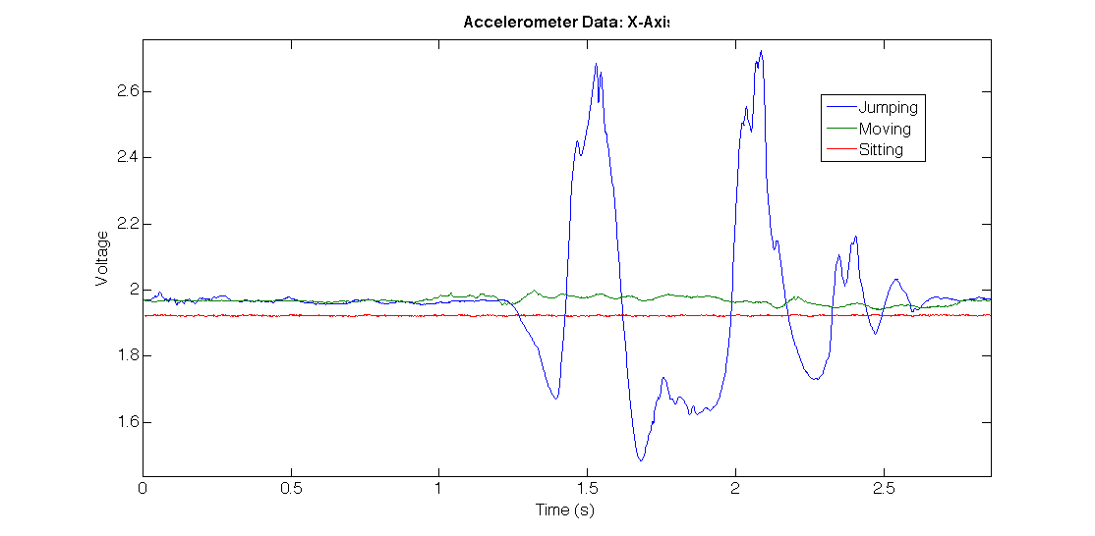

(a)

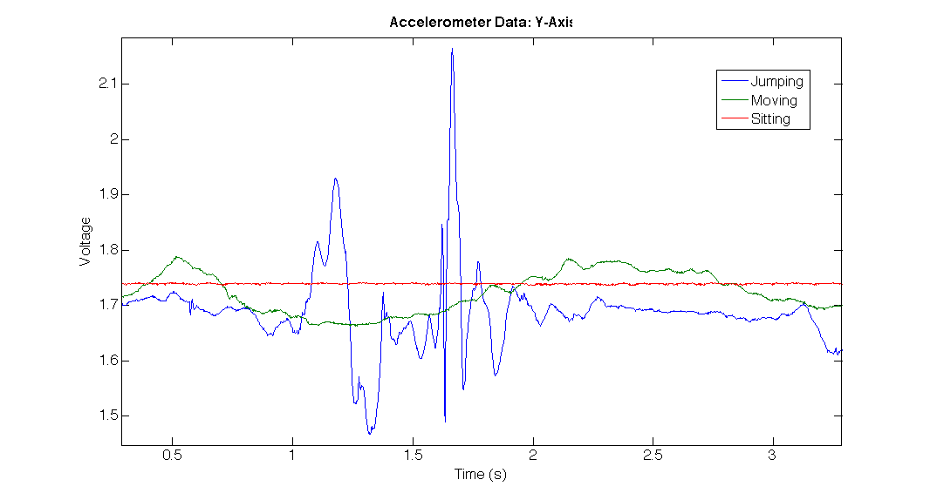

(b)

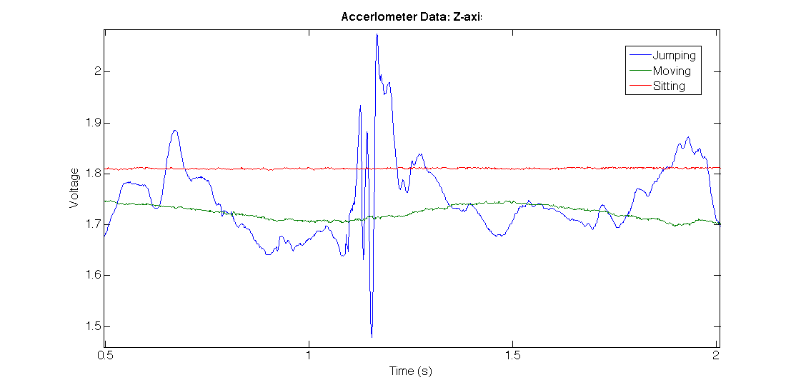

(c)

Figure : (a) Accelerometer data from the x-axis, (b) accelerometer data from the y-axis, and (c) accelerometer data from the z-axis.

Section 6.1.3 discusses further accelerometer testing in the Spring Semester.

## Bluetooth Low Energy

Bluetooth Low Energy (BLE), also referred to as Bluetooth Smart, is the newest, power-efficient version of Bluetooth wireless technology. BLE supports transfer of very short data packets, with all connections using sniff subrating, thus significantly reducing the duty cycles of the device. BLE is perfect for devices that need to run for a long period of time on a limited power supply.

BLE employs the Generic Attribute Profile (GATT) to organize and control the data transfer between devices. There are two types of GATT: server and client. The GATT server stores data, processes requests sent by the GATT client, and sends notifications and indication to the GATT client when special events occur.

The GATT profile may contain several services, with each service containing multiple characteristics. A service contains data, and information on how that data should be communicated to other BLE devices. A characteristic further describes different parts of a service. Each characteristic might include descriptors that further organize the data in the characteristic. Figure 20 below shows the general structure of the GATT profile, with different services, characteristics and descriptors.

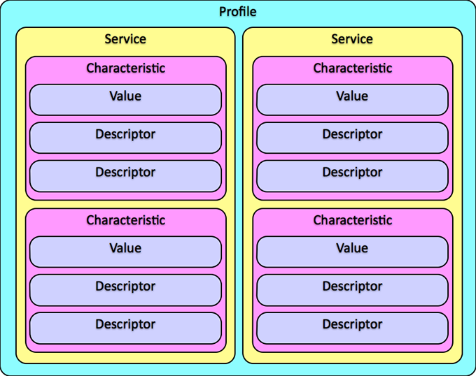

Figure : [CITATION]

## WICED SMart BLE and Microprocessor

### Structure of WICED and Incorporation of BLE

The WICED Smart includes a fully built-in LE stack, with the Generic Access Profile (GAP) and Generic Attribute Profile (GATT) incorporated on top of lower-level layers that take care of the physical transfer of data. The GAP controls advertisement and connection of BLE devices, while the GATT defines how data is transferred once connection is established. Figure 21 below shows the full LE stack built into the WICED Smart.

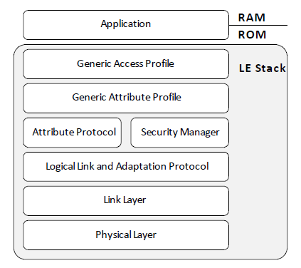

Figure : CAPTION

Because the WICED is optimized for Bluetooth Low Energy, all functionalities of the WICED, including accessing peripherals such as GPIOs and UART, have to be initiated through the LE stack. A typical application for the WICED includes initialization of the GATT database, followed by device configuration and peripherals configuration. When the configurations are completed, the application becomes entirely event driven, allowing the WICED to react only when required. This contributes greatly to the power efficiency of the system. Figure 22 below shows the typical application initialization sequence, all of which has to be done through the LE Stack.

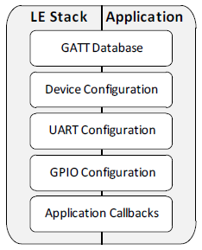

Figure : CAPTION

To help with developing for the WICED, Broadcom also release the Software Development Kit for the WICED Smart. The SDK includes all the libraries needed to fully utilize the LE Stack for BLE communication.

### Progress: Interaction with GPIOs, ADC and Timers

To get a better sense of the WICED, the team decided to build a simple program that reads in an analog signal from a potentiometer and controls the LED based on this signal, while at the same time sending the signal to a general purpose mobile application via BLE.

Since the WICED is event-driven, with no continuously running loop that executes preprogrammed commands, the fine timer is invoked as events. More specifically, the application on the WICED will execute commands every time the fine timer ticks. The period of the fine timer, as well as the mapping between the events and the commands, could be controlled through the bleapp library configuration and functions. For the sample application, the fine timer is set at its highest resolution, with period of 12.5 ms. The fine timer ticks are registered as events, and the bleapp library map these to a function where commands are programmed. When the app is running, it will call on this function every time the fine timer ticks.

The GPIOs library is initialized also through the bleapp library. Afterward, however, all GPIOs control can be accessed through the gpiodriver library. For the sample app, pin 14, which is also the LED pin, is initialized as an output, while pin 32 is set up as analog input, using additional function from the adc library. In the fine timer callback function, the app is programmed to read in the analog signal from pin 32. If the analog signal is higher than half of the power supply, the LED is turned on using a function in the gpiodriver library. If not, the LED remains off.

The GAP and GATT database for the app is set up using the WICED Smart Designer. There are three services. The required Generic Access and Generic Attribute, along with the vendor specific service named potentiometer. The potentiometer service includes one characteristic: the potentiometer value. The WICED Smart Designer further divides the potentiometer value characteristic into 2 descriptors, one containing the name of the characteristic, and another containing the value of the characteristic. Each service, characteristic and descriptor is assigned a unique handle.

### Data Transfer Through BLE

With the GAP and GATT set-up, transferring data via BLE requires calling a function from the bleapp library that writes data to a handle. In the sample app, the mobile application manages to read the potentiometer data sent by the WICED. Since the purpose of the sample application is to navigate through the basic libraries of the WICED, the team did not do extensive testing on the calibration of the GPIO analog reading, as well as the accuracy of the value read by the mobile application. However, there is clear correspondence between the potentiometer shifting and the value read shifting. The team will definitely do more testing on the ADC and the data accuracy after transfer in the future.

At the moment, only 8 bits of data are transferred at a time. The bleapp function that writes to handles only writes 8 bits at a time. In order to overcome this and send longer data, the handle needs to be linked to the NVRAM. That way, the GATT database could read longer sequence of bits directly from the NVRAM. Currently, this is not yet implemented in our sample application. However, the team will incorporate this in the design of the final application.

### Final Application Design

For the application to be used with the health monitoring system, the GATT database will have 4 more services aside from the required GAP and GATT. There will be a service for each of the sensor, and there will be an additional battery service that keeps the mobile application updated with the battery information of the WICED.

Data collected from each sensor will be placed in the NVRAM. When the client issues a read request, the GATT database will send whatever in the specified NVRAM to the client. The GATT server on the WICED will issue notification when the sensors are not connected or when the battery is low.

## Android Mobile Application

The purpose of incorporating a mobile application to the prototype is to support data transfer. The mobile application uses BLE as a method of transferring data taken in by the WICED and subsequently storing that data in the cloud. For this project, the mobile application was developed for Android devices using the Android Studio compiler.

The structure of the code is divided into seven steps. First, the application checks whether the phone running the application has Bluetooth Low Energy capabilities, and if so, the phone will move to the next step and ask for permission to turn on BLE, then activate it if permission is granted. This ensures that the user is aware that BLE is on, which is important to know for cell phone battery life. Third, the application scans for BLE devices. It is possible to scan for all available devices, but for the purposes of this project, the application only needs to detect that the WICED Smart is running the appropriate program.

As mentioned in Section 5.4, BLE uses GATT servers to specify how data is transferred between the central and peripheral devices. In this case, the cell phone is the central device because it scans for “advertisements” made by peripheral devices and the WICED Smart is the peripheral device because it broadcasts itself as an available BLE device. Once the application identifies the specific device, it connects to the GATT server. Next, the application reads the GATT server and identifies the BLE attributes and the corresponding characteristic(s) accompanying the device. In this project, the characteristics correspond to packaged sensor readings.

The sensor readings should include data from the accelerometers, respiratory bands, and ECG electrodes. While possible for one Android application (as a central device) to connect to multiple peripheral devices (in this case, multiple GATT servers that communicate different sensor readings), the team has chosen to package the data into one GATT server as a long string of bits. Each sensor may have different sampling rates; however, by concatenating all the data into a string of bits, the WICED Smart only has to worry about sending one string of bits through BLE rather than multiple strings. Second, for Android BLE communication, connecting to multiple devices requires either programming delays between each “command”—for example, between reading or writing each set of data—or implementing a state machine involving all the different devices. This increases the complexity of the code, therefore, the structure adopted for this semester was the mobile application accepting one string of bits from the WICED Smart and parsing the string into the appropriate data values [23].

## Overall System Design

*This section is often the heart of a Midyear Report. It should fully document the design. Common figures and tables in this type of section include block diagrams, detailed drawings, schematics, printed circuit board layouts, and a bill of materials (BOM). The section should explain why design decisions were made, such as how tolerances were selected or why certain component values were used.*

*A bill of materials should list everything that the reader would need to order the components. Component designations should match those in the detailed drawing or schematic to assist assembly. An example is shown in Table 1.*

Table 2 Bill of Materials

|  |  |  |  |  |  |  |
| --- | --- | --- | --- | --- | --- | --- |
| **Component** | **Description** | **Supplier** | **Supplier Part #** | **Unit Price** | **Quantity** | **Total** |
| R1-R7 | 1 k resistor | DigiKey | 1.0KQBK-ND | $0.01 | 7 | $0.07 |
| C1 | 0.1 F capacitor | DigiKey | P4525-ND | $0.18 | 1 | $0.18 |
| U1 | Spartan XCS3400-4TQ144C FPGA | Nu Horizons | XCS400-4TQ144C | $19.10 | 1 | $19.10 |
| D1 | Common anode 7-segment display | Jameco | 24715 | $1.26 | 1 | $1.26 |
| … |  |  |  |  |  |  |

*If the design includes source code, the body should give an overview of the design and operation, but the code should be placed in an appendix.*

# Test plan

## Component Testing

### ECG

### Respiratory Band

In order to test the respiratory circuit, a number of steps will be taken.

Power Testing

In order to test the power draw of the circuit, the team will check the amperage drawn from a power source for the circuit. This will be tested over a range of changing inductances, to determine in the stretching of the band dramatically increases the current draw.

Signal Integrity Testing

These tests will be used to determine the quality of the signal under a variety of adverse conditions. One possible test will involve determining how motion will affect the quality of the signal. An experimenter will wear the respiratory belt, and data will be collected while the subject is lying down and turning (while they are asleep), sitting, walking, and running. This data will then be analyzed for the presence of motion artifact. More testing will be done to determine how moisture, simulating a sweating patient, will change the signal.

Noise Reduction Testing

After completing the signal integrity tests, a series of tests will be used to determine the effect of noise reduction measures on the circuit. Filtered data will be compared to unfiltered data, and analysis will be performed after each new circuit element is added in order to ensure the signal integrity is maintained.

Calibration

In order to transform the change in frequency measured by the circuit to the change in length that the respiratory band experiences, the team will perform a complete calibration. This will involve stretching the band increasing amounts and correlating the change in frequency to the change in length. Further testing will use these initial results to determine how the rate of breathing corresponds to this change in length.

### Accelerometer

During the Fall Semester, the accelerometer was setup and tested for functionality. The team was able to verify that the sensor output three different voltage signals that corresponded to the x-, y-, and z-axis. However, more work will be done in the Spring Semester to quantify the output voltages. First, the accelerometer will be calibrated using the Harvey Mudd College Engineering Department’s turntable. Using the turntable, the sensor will experience a known acceleration on all three axes. A calibration curve will be created that calculates a relationship between the accelerometer output voltage and the acceleration measured.

Second, the sensor will be tested on the body. The tester will try a variety of positions including standing still, rolling around (as if sleeping), and walking. From this data, the team can make preliminary observations about what the accelerometer data will look like during certain phenomena. This can help differentiate between what may be noise and what is substantial movement. The accelerometer will be tested in parallel with the respiratory band and ECG so that observations can be made about how accurate the accelerometer can detect motion and pinpoint motion artifact in the other sensors.

### WICED Smart

#### GPIOs

To test the GPIOs, each of the accessible pins from the WICED will be written to. The output will be measured by a multi-meter. To test both digital input and output functionalities, the timer could be used to write a clock signal to the pins. The pins will all be driven to low at first. Once the application enters callbacks mode, the pins will be read every timer tick. If the pin reads high, the callback function will set the pin to low, and vice versa. As the app runs, an oscilloscope will be used to check the output of the pins and ensure acceptable behavior.

#### ADC

Testing the ADC includes both calibrating the ADC and testing the functionalities of the ADC. To calibrate the ADC, the sample potentiometer application could be used to record a set of data consisting of the analog voltage coming into the pin (measured by a multi-meter) and the value read by the WICED. With that set of data, mapping between the actual voltage and the value read can be decided.

After the calibration is completed, the potentiometer application will be modified to do take in values from a potentiometer from different pins. The resulting value will be compared to the calibration data set to ensure consistent behavior of ADC across different pins.

#### Data Transfer

The data transfer can be tested using the potentiometer application. Since the application sends the analog data from the WICED to the mobile application, the value read from the mobile application can be checked against the value read after the ADC on the WICED. These two values should match closely.

Once the NVRAM could be set up such that longer stream of data could be sent via BLE to the mobile application, the debugging UART can be set up to print out the value written in the NVRAM. The value read on the debugging UART should match the one displayed on the mobile application.

### Android Mobile Application

This semester, the mobile application was tested concurrently with application development. During the Spring Semester, the mobile application will be tested for completeness and flow with the whole health monitoring system once the system is assembled. The application will be tested for the strength of the Bluetooth Low Energy connection. The application will be downloaded into multiple Android devices and the maximum range the device can connect to the WICED Smart will be measured, giving future users a threshold working range.

An important part of the mobile application deliverable for next semester is the cloud storage. Thus, the whole system will have to be tested with signature events (i.e. standing still, walking, and running) performed at specific time intervals. The person analyzing the data received from the cloud can use these signature events to verify that the data stored in the cloud matches the data recorded by the sensors. While the end-product application will not display data for the patient to see, a version of the application will likely display the values it is receiving from the microprocessor to provide intermediary values between the sensors and the cloud storage.

### Data Storage

Testing the data storage system involves testing the WICED’s ability to reliably write to the Micro SD card, and the card’s readability on a standard computer. A simple WICED application can write preprogrammed data to the Micro SD card. Once the write is completed, the card will be read on a different system, most likely a computer. The value written to the card by the WICED should match the value read from the card by the computer.

Once it is ensured that the WICED can write reliably to the Micro SD card, the team will test the data storage system on a real system. This means that the team will connect one or more sensors to the WICED and make sure that all the data recorded by the WICED is written to the Micro SD card.

## System Testing

*A test plan explains the specific objectives of the test and gives a procedure for conducting the test. In many cases, it should also list materials or equipment required for the test. When testing has safety issues, the procedure should specifically address these issues. Common problems with a test plan are that the objectives are not defined precisely enough, that the procedure is not spelled out clearly enough to follow unambiguously, or that the tests are insufficient to reach the stated objectives.*

# Project Management

*By this point, you will likely have obtained new information not available at the time of the Work Plan that causes the plan for the project to shift in minor or major ways. You also are likely to have a much better sense of which parts of the project are easy and which parts are hard. This section is a good place to critically reflect on how the fall semester actually proceeded in comparison to your plan and to use the experience to create an effective spring plan.*

[Introduction here, you should not have two headings in a row without text between.]

## Fall progress

*Discuss what the team completed in the fall and how it matched the Work Plan in terms of deliverables, schedule, and division of labor. Include a comparison of the fall elements from the work breakdown structure with the actual work performed. The comparison will show new tasks added to the work beyond the original plan. Review the minutes from the team meetings. If the project deviated from the plan, why did the deviations occur? What can the team learn from the experience to create a more realistic plan to reach the spring deliverables?*

The work breakdown structure in Figure 14 shows how the project has been hierarchically subdivided into more manageable tasks.

**Activity Time Time (predicted) (actual)**

Background research *(already complete)*

Opioids 2 2

Naloxone 2 2

Current Technologies

ECG 6 6

Respiratory Rate 6 6

Motion 6 6

Conceptual Design

Research

Embodiment 2 2

Bluetooth module 8 6

Brainstorming, sketching, component research

ECG 6 4

Conductive materials/fabrics 6 4

Respiratory Rates 6 7

Motion 6 2

Bluetooth module 6 6

Drawings

Embodiment design 4 3

Hardware 10 10

Mobile application 2 1

Comparison of Alternatives 10 5

Detailed Design *(significant uncertainty in these initial estimates)*

Component selection 20 5

Assembling hardware 30 30

Microprocessor programming 30 80

Microprocessor data storage 30 1

Mobile application programming and connection to cloud 60 25

Revised analysis 10 7

Revised components 10 7

Test Plan

Initial Test Plan 4 1

Revised Test Plan 2 1

Testing *(significant uncertainty in these initial estimates pending test plan development)*

Initial prototype testing

Sensor accuracy 6 4

Comfort/durability 6 0

Data storage 6 0

Battery life 6 1

Revised prototype testing

Sensor accuracy 4 0

Comfort/durability 4 0

Data storage 4 0

Battery life 4 0

Team Meetings

Teleconferences 120 64

Internal Team Meetings 480 320

Tuesday Presentations 120 48

Team Leader Meetings 7 10

Planning 30 × 0.5 = 15

Logistics

Register to drive Clinic Van 2 0

Presentation and Preparation

Orientation Day 12 12

Fall Review #1 8 8

Fall Review #2 12 4

Fall Review #3 12 4

Fall Site Visit 192 192

Spring Presentation 24 0

Projects Day Presentation 24 0

Spring Site Visit 192 0

Reports

Team Charter 5 6

Work Plan

Background 5 4

Design Alternatives 5 4

Project Management

Work Breakdown 4 2

Schedule 2 3

Division of Labor 1 1

Other sections 3 4

Writing Center review 2 0

Midyear Report 40 40

Final Report 80 0

Total Time 1705 960

Figure : Work Breakdown Structure

## spring overview

[Lay out the big picture of what the team plans to do in the spring, how the work will be divided, and what the major milestones are along the way.]

## Work Breakdown Structure

**Activity Time (hours)**

Initial Prototyping *(significant uncertainty in these initial estimates)*

Circuit optimization 16

Mobile application connection to the cloud 10

Microprocessor data storage 20

Embodiment design drawing 5

Assemble embodiment design 30

Assemble circuit on perf board 30

Measure system power 10

Test Plan

Initial Test Plan 4

Revised Test Plan 2

Testing *(significant uncertainty in these initial estimates pending test plan development)*

Initial prototype testing

Sensor accuracy 6

Comfort/durability 6

Data storage 6

Mobile application communication 6

Battery life 6

Revised prototype testing

Sensor accuracy 4

Comfort/durability 4

Data storage 4

Mobile application communication 4

Battery life 4

Team Meetings

Teleconferences 15 × 4 × 1 = 60

Internal Team Meetings 30 × 4 × 4 = 480

Tuesday Presentations 30 × 4 × 1 = 120

Team Leader Meetings 7

Planning 30 × 0.5 = 15

Logistics

Register to drive Clinic Van 2

Presentation and Preparation

Spring Presentation 6 × 4 = 24

Projects Day Presentation 6 × 4 = 24

Spring Site Visit 48 x 4 = 192

Reports

Final Report 80

Outline

Draft 1

Draft 2

Writing Center review

Final Draft

Total Time

Figure : Spring Work Breakdown Structure

## Schedule

[See work plan. Focus on spring semester Gantt charts.]

Figure 25 Spring Gantt chart

Figure 26 Detailed Spring Gantt chart

## Division of labor

[Similar to work plan, but for spring semester tasks]

**Activity Owner**

Conceptual Design

Embodiment Ng

Bluetooth module Roley

Detailed Design

Component selection Ng

Sensor to processor connection Roley

Microprocessor data storage Nguyen

Microprocessor encoding Roley

Mobile application programming Zheng

Bluetooth pairing between module and mobile phone Zheng

Revised analysis Zheng

Revised components Ng

Test Plan Nguyen

Testing TBD

Presentation and Preparation All

Reports All

# References

1. *Dr. Stephen J. McCormack.* [Online] Available: <http://www.exela.com/>.
2. *Stony Brook Medicine.* [Online] Available: <http://stonybrookmedicine.edu/>
3. *Opioids*. [Online] Available: <http://www.drugabuse.gov/publications/research-reports/prescription-drugs/opioids>.
4. A. Preda. *Opioid Abuse*. Available: <http://emedicine.medscape.com/article/287790-overview#aw2aab6b2b3>.
5. *Understanding Naloxone.* [Online]. Available: [http://harmreduction.org/issues/overdose-prevention/overview/overdose-basics/understanding-Naloxone/](http://harmreduction.org/issues/overdose-prevention/overview/overdose-basics/understanding-naloxone/).
6. *Naloxone Injection*. (2014, May 15). [Online]. Available: <http://www.nlm.nih.gov/medlineplus/druginfo/meds/a612022.html>.
7. M.M. Straus, “Preventing deaths from rising opioid overdose in the US – the promise of Naloxone antidote in community-based Naloxone take-home programs,” *Substance Abuse and Rehabilitation*, vol. 4, pp. 65-72, 2013.
8. S. F. J. Clarke, “Naloxone in opioid poisoning: walking the tightrope,” *Emerg Med J.*, vol. 22, pp. 612-616, Apr. 2004.
9. *Overdose Prevention Campaign: Expanding Access to Naloxone.* (2014). [Online]. Available: <http://www.drugpolicy.org/departments-and-state-offices/new-jersey/overdose-prevention-campaign/overdose-prevention-3>.
10. *Biometric shirts for performance improvement and sleep tracking*. (2014) [Online] Available: [http://www.hexoskin.com](http://www.hexoskin.com/)
11. Soltera Wireless. (Oct 9, 2013) *VisiMobile: Monitoring in Motion*  [Brochure]. Place: San Diego.
12. Soltera Wireless. (Oct 9, 2013) *VisiMobile: Monitoring in Motion*  [Brochure]. Place: San Diego.
13. ZephyrLIFE HOME - Remote Patient Monitoring System - Zephyr Technology Corporation. (n.d.). Retrieved September 29, 2014.
14. *Intel® Edison*. [Online] Available: <https://www.sparkfun.com/products/13024>.
15. *Wireless Solutions WICED™ Smart.* (2014). [Online] Available: <http://community.broadcom.com/servlet/JiveServlet/previewBody/1514-102-3-1505/MMPWICEDSmart-HS101-R.pdf>.
16. *Panasonic PAN1026-SPP+GATT-ETU* (2014). [Online] Available: [http://octopart.com/pan1026-spp%2Bgatt-etu-panasonic-29717399](http://octopart.com/pan1026-spp+gatt-etu-panasonic-29717399).
17. *Panasonic PAN1026 Bluetooth® 4.0 Module*. [Online] Available: <http://www.mouser.com/new/panasonicec/panasonic-pan1026-bluetooth-module/>.
18. *MSC: development kit simplifies implementation of PAN1026 Bluetooth module.* [Online] Available: <http://www.embedded-control-europe.com/tools-software/4-tools-software/1212-msc-development-kit-simplifies-implementation-of-pan1026-bluetooth-module>.
19. *Bluefruit LE – Bluetooth Low Energy (BLE 4.0) – nRF8001 Breakout – v1.0.* [Online] Available: <http://www.adafruit.com/products/1697>.
20. *LilyPad Arduino*. [Online] Available: <http://arduino.cc/en/Main/arduinoBoardLilyPad>
21. *SparkFun Triple Axis Accelerometer Breakout –ADXL335*. [Online] Available: <https://www.sparkfun.com/products/9269>.
22. *Small, Low Power, 3*-*Axis ±3 g Accelerometer.* [Online] Available: <https://www.sparkfun.com/datasheets/Components/SMD/adxl335.pdf>.
23. *API Guides: Bluetooth Low Energy.* [Online] Available: <https://developer.android.com/guide/topics/connectivity/bluetooth-le.html>.

1. Full embodiment design means that all the sensors included in the system are connected to a central hub.